Automatic Sorting Robot Project

By: Caleb Capps

Date: 8/12/2022

# Project Introduction

Outline projects goals, organizational structure, and design process used to both generate solutions and to evaluate results. A Gantt chart outlining key deliverables and due dates might be useful to keep everything organized

  
Figure XXX – Project Gantt Chart

# Device Function and Requirements

…

## Device Specifications

These come directly from the project outline document

## Device constraints

These come directly from the project outline document

Functional requirement table

# Overview of Design Process

Description of mechanical, software, and electrical interactions

  
Figure XXX – Black Box Diagram

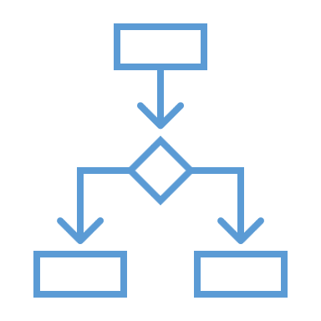

Figure XXX - Functional Structure Block Diagram

Solution idea tables

Table XXX – Solution Ideation Table

|  |  |  |  |  |
| --- | --- | --- | --- | --- |
| Function | Solution 1 | Solution 2 | … | Solution n |
| Process function 1 |  |  |  |  |
| Process function 2 |  |  |  |  |
| … |  |  |  |  |
| Process function n |  |  |  |  |

Solution rank matrices…

Solution choice…

# Design Evaluation

Description of design components, testing methods, and any brief findings

## Initial Design Concept

This should contain a detailed description of the mechanical, electrical, and control systems used for each design, including:

1. CAD models & drawings,
2. electrical diagrams, and
3. a copy of any code files (and screenshots of data readout if applicable).
   * A flow chart could be helpful to display how the control scheme functions graphically

### Description of Mechanical Design & Assembly

…

### Description of Electrical Design & Assembly

…

### Description of Controls Scheme

…

## Design Revision A

This should contain a detailed description of the mechanical, electrical, and control systems used for each design, including:

1. CAD models & drawings,
2. electrical diagrams, and
3. a copy of any code files (and screenshots of data readout if applicable).
   * A flow chart could be helpful to display how the control scheme functions graphically

This and following revisions should be shorter than the original design description, only outlining any changes to the design from one revision to the next.

# 5. Results

…

# 6. Conclusion

…

# Appendix A – Mechanical Drawings

…

# Appendix B – Electrical Diagrams

…

# Appendix C – Code & Controls

…